AWS EC2 AND S3
Agenda
- Connection of EC2 instance by SSH Client
- Introduction to S3
- Key Features of AWS S3
- Components of AWS S3
- Use Cases of S3
- Object Storage and Immutability
- S3 Naming Conventions
- Region and Availability Zones
- Amazon S3 Storage Classes
- Creation of Bucket
Connection of EC2 instance by SSH Client:
Secure Shell (SSH) is a protocol that provides a secure way to access and manage remote servers, such as AWS EC2 instances. In AWS, SSH authentication is achieved using a key pair consisting of a public and private key. The public key is stored on the instance, while the private key is securely kept by the user. During the connection process, SSH uses this key pair to establish an encrypted session, ensuring secure data transfer and preventing unauthorized access. To enable SSH access, the instance’s security group must allow inbound traffic on port 22.
To connect to an EC2 instance, users download the private key (.pem file) at the time of key pair creation and use it with an SSH client. On Linux or Mac, the ssh command is used, while Windows users can use tools like PuTTY or PowerShell. It is crucial to secure the private key by setting restrictive file permissions (e.g., chmod 400 on Unix-like systems) to prevent unauthorized use. For enhanced security, AWS recommends restricting SSH access in security groups to specific IP addresses and considering alternative methods like AWS Session Manager for accessing instances without exposing port 22.
Firstly, start the Instance created in the last class and also create a new Elastic IP and associate the Elastic IP with the instance again.
Step 1: Connect to the Instance Using the Elastic IP and SSH Client
After starting your EC2 instance and assigning an Elastic IP (if not already done), navigate to the AWS Management Console. Go to the Instances section, select your running instance, and click on the Connect button. Choose the SSH Client tab to see the connection details and example commands for accessing your instance. Ensure you have the key pair file (downloaded during key pair creation in the last class) saved securely on your computer, as it is required for authentication.
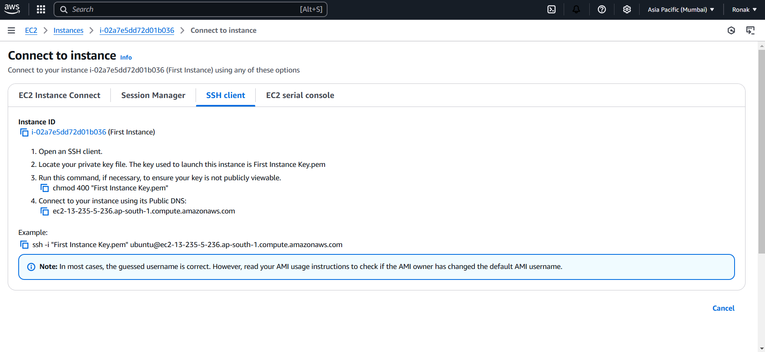
NOTE: Ensure the key pair file downloaded in Step-4 of last class is present in your computer as we are using same instance
Step 2: Verify SSH Installation on Your ComputerOpen Command Prompt (Windows) or Terminal (Mac/Linux). Check if SSH is installed by typing:
ssh
If SSH is installed, a list of available options and commands will appear. If it isn’t installed, you need to install an SSH client:
- Windows: Install OpenSSH Client via Windows Features.
- Linux/Mac: SSH is pre-installed on most systems.
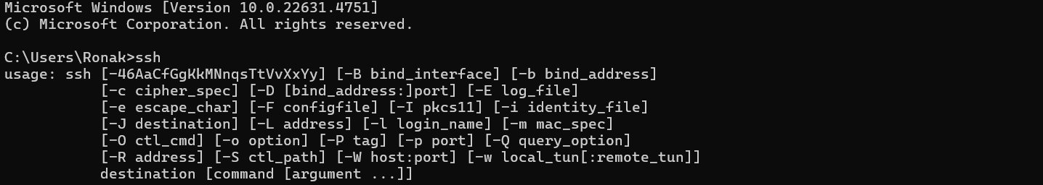
Step 3: Now, go to Downloads by command cd Downloads/ and then write dir in Windows and in case if you are using Linux or Terminal then type ls and now the list of files on Downloads will appear like this.
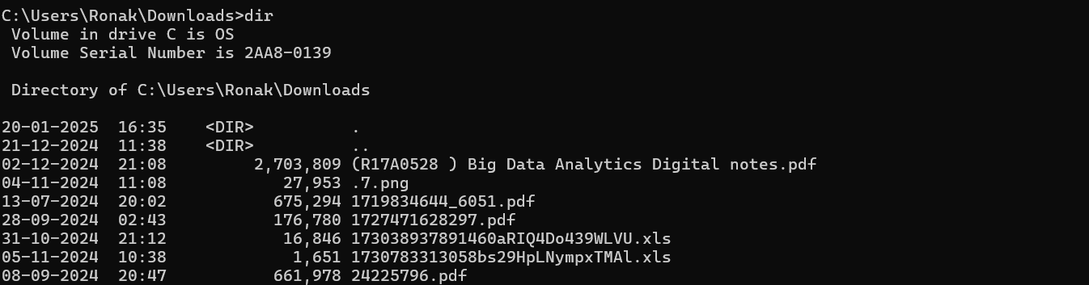
Step 4: Now, use the following command for windows to access the downloaded key and for Linux use directly write the name of the key
Step 5: Now, to give a connected instance, copy the example from AWS console.
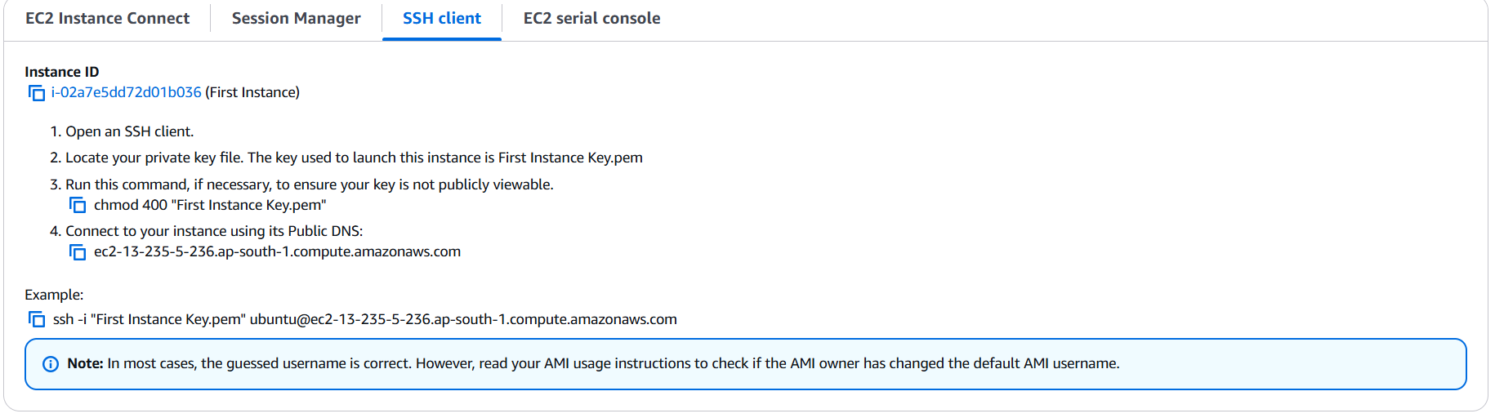

Then run
Step 6: Now, it will ask for Yes or no, type yes and ubuntu will appear, and ubuntu instance is now connected to your Command line and you can perform operations and this is not the command line of your computer but the command line of the instance(machine) created on AWS.
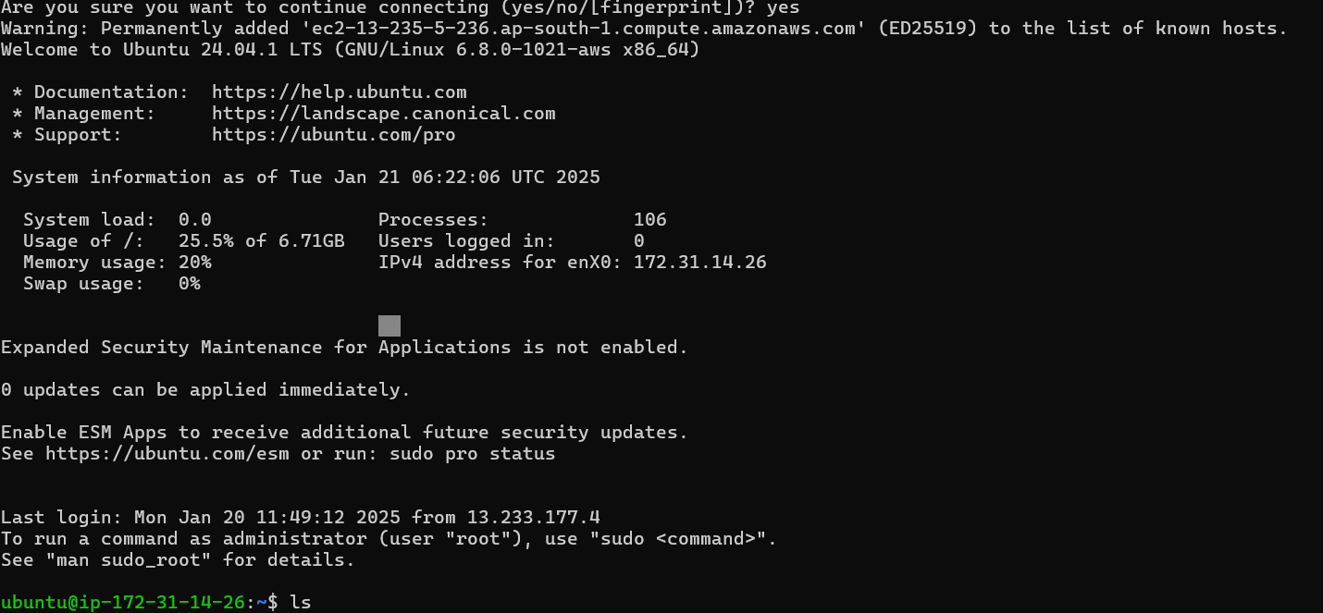
Step 7: Like run sudo apt-get update like this.
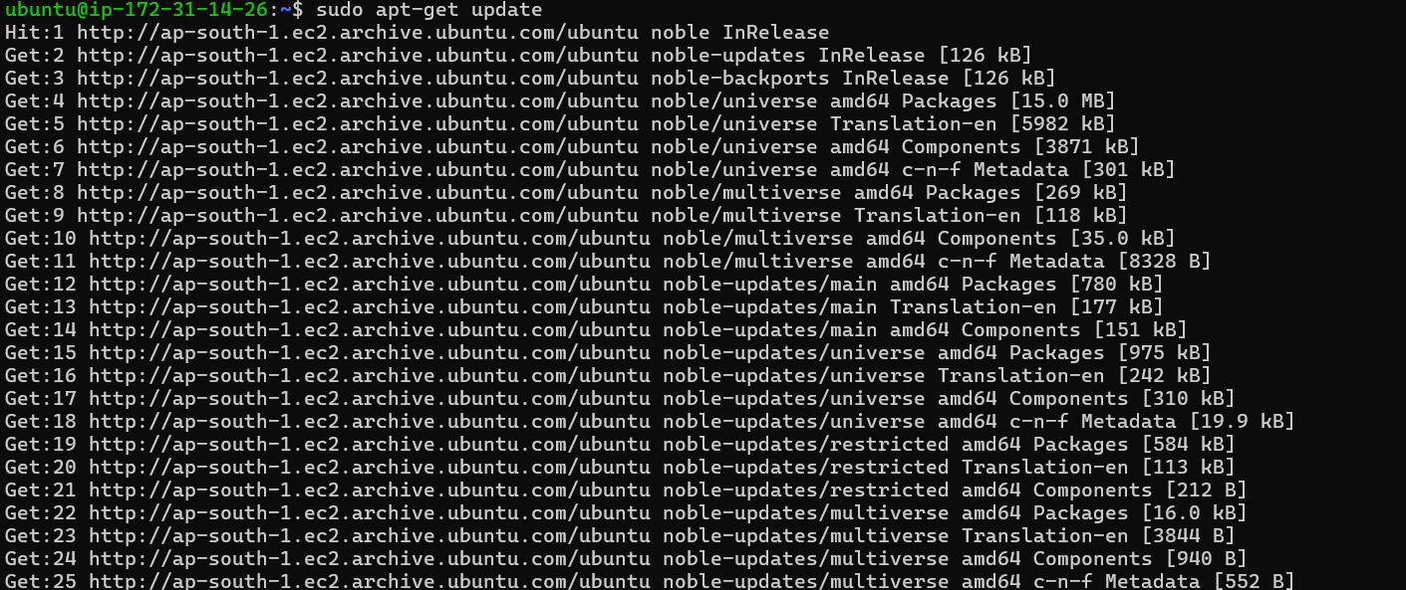
Step 8: To stop working, you can type exit in the terminal to close the SSH session. When you stop the instance from the AWS Console, the SSH connection will terminate automatically. Note that stopping the instance shuts down the virtual server, but you can restart it later with the same Elastic IP and configuration.
Introduction to S3:
Amazon S3 (Simple Storage Service) is an object storage service provided by Amazon Web Services (AWS). It allows users to store and retrieve any amount of data at any time, from anywhere on the web. This service is highly scalable, durable, and secure, making it a preferred choice for many use cases such as backup, archiving, data lakes, web hosting, and more.
Key Features of Amazon S3:
- Scalability:
  - Elastic Scalability: S3 automatically scales to accommodate growing storage needs. It can handle large volumes of data and is designed to scale easily without requiring any manual intervention.
  - Unlimited Storage: You can store any amount of data in S3. There's no need to worry about running out of space, making it ideal for applications with growing or unpredictable data needs.
- Durability and Availability:
  - 11 9's Durability: Amazon S3 offers 99.999999999% (11 9’s) durability, meaning your data is extremely unlikely to be lost.
  - Multiple Storage Classes: S3 uses various storage classes optimized for different use cases, allowing users to choose between cost-effective options (like Glacier for archiving) and high-availability options (like S3 Standard).
  - Data Redundancy: Data stored in S3 is redundantly stored across multiple physical locations to ensure durability. Even if a location experiences failure, the data remains accessible.
- Security:
  - Encryption: Amazon S3 supports data encryption both in-transit (while data is moving) and at rest (when it is stored). Users can encrypt data using AWS Key Management Service (KMS) or their own keys.
  - Access Control: Access to S3 objects is controlled through Identity and Access Management (IAM) policies, bucket policies, Access Control Lists (ACLs), and S3 Block Public Access settings to ensure only authorized users can access the data.
  - Logging and Monitoring: S3 provides built-in logging and monitoring capabilities through AWS CloudTrail and Amazon CloudWatch to track access requests and monitor the health of your storage system.
- Performance:
  - Low Latency: S3 provides high throughput and low-latency performance, allowing for fast access to data. This is particularly useful for applications such as web hosting, data analytics, and content delivery.
  - Content Delivery Integration: Amazon S3 integrates seamlessly with Amazon CloudFront, a Content Delivery Network (CDN) service that caches data closer to the end users to improve access speed.
- Cost-Effective:
  - Pay-As-You-Go: S3 follows a pay-per-use pricing model, which means you pay only for the storage and services you use, without upfront costs or long-term commitments.
  - Storage Classes: S3 offers multiple storage classes to meet different data access needs, from high-performance to archival solutions, each with different pricing models.
    - S3 Standard: For frequently accessed data.
    - S3 Intelligent-Tiering: Automatically moves objects between two access tiers when access patterns change.
    - S3 Standard-IA (Infrequent Access): For data that is accessed less frequently.
    - S3 Glacier and S3 Glacier Deep Archive: For long-term archival storage with cost-effective pricing.
- Data Management:
  - Versioning: S3 supports versioning, allowing you to preserve, retrieve, and restore every version of every object stored in a bucket. This helps with disaster recovery and tracking changes.
  - Lifecycle Policies: You can configure lifecycle policies to automatically transition objects between storage classes or delete them after a certain period.
  - Event Notifications: S3 can send event notifications for actions such as object uploads, deletions, or changes. These notifications can trigger workflows, Lambda functions, or other processes.
- Data Accessibility and Integration:
  - Web Interface: S3 provides a web-based management console that allows you to easily upload, manage, and access your data.
  - API Access: S3 is accessible through RESTful APIs, SDKs, and AWS CLI (Command Line Interface). This provides programmatic access to objects and data within S3, enabling automation of various tasks such as uploading files, downloading data, or managing storage.
  - Cross-Region Replication: S3 allows you to replicate objects across different AWS regions for disaster recovery, compliance, or latency optimization.
Components of AWS S3:
- Objects:
In Amazon S3, data is stored as objects. Each object consists of:
- Data: The actual content or file being stored, such as a text file, image, video, or log file.
- Metadata: Key-value pairs that provide additional information about the object, such as the file type, size, or custom attributes.
- Unique Identifier (Key): The key is a unique string used to identify the object within a bucket. The key is essentially the object's name and location in the bucket.
Object Characteristics:
- Maximum Object Size: An object can be up to 5 TB in size, although uploads greater than 5 GB are typically handled using multipart upload.
- Versioning: When versioning is enabled, each object can have multiple versions, each identified by a unique version ID.
- Buckets:
A bucket is a container in which objects are stored. Each bucket is a globally unique entity within S3.
Characteristics:
- Global Uniqueness: The name of each bucket must be globally unique within S3, which means no two accounts can have buckets with the same name.
- Bucket Permissions: You can configure access to your bucket and its contents using Access Control Lists (ACLs), Bucket Policies, and IAM Policies.
- Region Selection: Buckets are associated with an AWS region, ensuring data is stored in the chosen region for low-latency access and compliance.
- Storage Classes:
S3 offers several storage classes, each optimized for different use cases, allowing users to select the most cost-effective option for their storage needs:
- S3 Standard: For frequently accessed data.
- S3 Intelligent-Tiering: Moves objects between two access tiers based on changing access patterns.
- S3 Standard-IA (Infrequent Access): For data that is accessed less frequently but needs rapid access when required.
- S3 One Zone-IA: For infrequently accessed data that is stored in a single availability zone (lower cost than Standard-IA).
- S3 Glacier: Low-cost, long-term archival storage with retrieval times ranging from minutes to hours.
- S3 Glacier Deep Archive: Even lower cost than Glacier for long-term storage with retrieval times of 12 hours or more.
- Versioning:
Versioning allows you to store multiple versions of the same object within a bucket. Each version is assigned a unique version ID.
Benefits:
- Data Protection: If an object is accidentally deleted or overwritten, previous versions can be restored.
- Tracking Changes: Useful for auditing and tracking changes to objects over time.
- Lifecycle Policies:
Lifecycle policies are rules that automatically manage the transition of objects between storage classes or delete objects based on predefined criteria.
Use Cases:
- Moving objects to lower-cost storage classes as they age (e.g., from S3 Standard to S3 Glacier).
- Automatically deleting objects after a certain period to optimize storage costs.
- Access Control:
- ACLs (Access Control Lists): ACLs allow you to define who can access your buckets and objects and what actions they can perform (e.g., read, write, or delete).
- Bucket Policies: Bucket policies are JSON-based access control mechanisms that provide more flexible control over permissions at the bucket level.
- IAM Policies: AWS Identity and Access Management (IAM) allows fine-grained access control, defining who can access specific objects or buckets based on user roles.
- Data Redundancy and Durability:
- 11 9's Durability: Amazon S3 offers 99.999999999% (11 9’s) durability, meaning your data is extremely unlikely to be lost. This is achieved through automatic replication of objects across multiple availability zones within a region.
- Data Replication: S3 ensures that your data is available even if one availability zone fails.
- Event Notifications:
- You can configure Amazon S3 to send notifications when certain events occur, such as an object being uploaded, deleted, or modified.
- Integration: These notifications can trigger actions like invoking AWS Lambda functions, sending messages to an SNS topic, or publishing events to an SQS queue.
- Cross-Region Replication (CRR):
CRR allows you to automatically replicate objects from one S3 bucket to another in a different AWS region.
Use Cases:
- Disaster recovery.
- Latency optimization for users in different geographical locations.
- S3 Static Website Hosting:
S3 can be used to host static websites by storing HTML, CSS, JavaScript, and other static content directly in an S3 bucket.
Benefits:
- Cost-effective and easy to set up.
- Integrates with Amazon CloudFront (CDN) to deliver content to users with low latency.
- Data Encryption:
- Encryption at Rest: S3 allows you to encrypt your data before it is stored, using either SSE-S3 (server-side encryption with S3 managed keys), SSE-KMS (using AWS Key Management Service), or your own encryption keys (SSE-C).
- Encryption in Transit: Data moving between your application and S3 is encrypted using HTTPS to ensure security.
- Tags:
S3 supports tags to add custom metadata to objects, which can help with organizing, tracking, and managing data.
Use Cases:
- Cost allocation (e.g., tagging objects by project, department, or business unit).
- Organizing data for easier retrieval and management.
- S3 Transfer Acceleration:
S3 Transfer Acceleration speeds up uploads and downloads to and from S3 by using a globally distributed network of edge locations.
Use Case: Useful for transferring large files to S3 from geographically distant locations.
- AWS S3 API and SDKs:
- Programmatic Access: S3 offers a set of RESTful APIs, SDKs, and a Command Line Interface (CLI) to interact with the service programmatically. These tools allow you to upload, download, and manage your objects and buckets.
- Integration with Other AWS Services: S3 integrates with many AWS services such as AWS Lambda, AWS Glue, Amazon EMR, and Amazon Athena, enabling advanced data processing and analytics.
Use Cases of S3:
- Backup and Archiving:
  - S3 is commonly used for backing up critical data and archiving files that need to be stored for long periods.
- Big Data Storage:
  - S3 serves as a central data lake for storing large datasets that can be analyzed using other AWS services like EMR, Redshift, or Athena.
- Static Website Hosting:
  - S3 can be used to host static websites (HTML, CSS, JS files).
- Media Storage:
  - It is used to store media files like images, videos, and audio, making them accessible to web applications and mobile devices.
- Log Storage and Processing:
  - S3 is ideal for storing logs from various sources, such as web servers, applications, and network devices, and processing them for analysis.
- Data Sharing and Distribution:
  - S3 makes it easy to share large datasets or files with others by generating pre-signed URLs that allow temporary access.
Object Storage and Immutability:
Object Storage:
- Amazon S3 uses an object storage model where data is stored as discrete objects in buckets.
  - Each object is identified by a unique key and can include metadata.
  - S3 does not store data in a traditional file hierarchy. Instead, it uses a flat structure but supports prefixes to mimic folder-like organization.
  - S3 is optimized for storing large volumes of unstructured data such as media files, backups, and logs.
Characteristics:
Immutability:
- Once an object is stored in S3, it is immutable, meaning its content cannot be modified. Instead, you can:
  - Overwrite the object with a new version (if versioning is disabled, the old data is replaced).
  - Store a new version of the object when versioning is enabled.
  - Enhances data integrity.
  - Useful for compliance scenarios where data must not be altered after being stored.
  - Ensures a reliable backup and archiving solution.
Benefits:
S3 Naming Conventions:
Bucket Naming:
- Requirements:
  - Bucket names must be globally unique across all AWS accounts.
  - Names must comply with DNS naming conventions.
  - Bucket names can contain:
    - Lowercase letters (a-z).
    - Numbers (0-9).
    - Hyphens (-).
    - Periods (.) between labels.
  - Names must be between 3 and 63 characters long.
  - Bucket names cannot contain uppercase letters, underscores, or adjacent periods.
- Best Practices:
  - Use descriptive and meaningful names (e.g., project-data-backup or website-static-content).
  - Avoid sensitive or confidential information in bucket names since names are visible in public URLs.
  - Use naming prefixes for organization (e.g., teamA-logs or projectX-archive).
Object Key Naming:
- Requirements:
  - Object keys can include:
    - Any UTF-8 encoded characters.
    - Special characters like /, -, _, and ..
  - Keys can be up to 1,024 bytes in length.
- Best Practices:
  - Use prefixes for logical organization, e.g., images/2025/photo1.jpg.
  - Avoid overly long or complex keys that can cause retrieval issues.
  - Use versioning or timestamps in keys to manage versions, e.g., logfile_20250121.txt.
Regions and Availability Zones:
Regions:
- A geographically distinct area with multiple data centers (Availability Zones).
- Purpose: Optimizes latency, ensures compliance with data residency laws, and ties each bucket to a specific region.
- Examples:
  - us-east-1 (North Virginia)
  - ap-south-1 (Mumbai)
  - eu-west-1 (Ireland)
- Benefits:
  - Reduces latency by placing data close to users.
  - Meets compliance and regulatory requirements.
Availability Zones (AZs):
- Distinct physical data centers within a region connected via low-latency networks.
- S3 Storage:
  - Data is automatically replicated across multiple AZs.
  - Ensures high availability and durability (99.999999999%).
- Benefits:
  - Protects against failures in any single AZ.
  - Guarantees uninterrupted access to data.
Amazon S3 Storage Classes:
Amazon S3 provides a range of storage classes designed to meet various use cases for cost, performance, and data access frequency. Each class offers a different balance of cost and availability tailored for specific requirements.
1. S3 Standard (General Purpose):
- Use Case: Frequently accessed data.
- Features:
  - High durability (99.999999999%) and availability (99.99%).
  - Low latency and high throughput.
  - Stores data redundantly across multiple Availability Zones.
- Examples:
  - Websites, applications, and data analytics.
2. S3 Intelligent-Tiering:
- Use Case: Data with unknown or changing access patterns.
- Features:
  - Automatically moves data between tiers (frequent and infrequent access) based on usage.
  - No retrieval fees or performance impact.
- Examples:
  - Machine learning data, unpredictable usage datasets.
3. S3 Standard-Infrequent Access (S3 Standard-IA):
- Use Case: Data accessed less frequently but requires rapid access when needed.
- Features:
  - Lower storage cost than S3 Standard.
  - Retrieval fees apply.
  - Same durability (99.999999999%) and slightly lower availability (99.9%).
- Examples:
  - Disaster recovery, backups.
4. S3 One Zone-Infrequent Access (S3 One Zone-IA):
- Use Case: Data that can be recreated easily or doesn’t require high availability.
- Features:
  - Stores data in a single Availability Zone (lower redundancy).
  - Lower cost compared to Standard-IA.
- Examples:
  - Secondary backups, non-critical data.
5. S3 Glacier Instant Retrieval:
- Use Case: Long-term data that is rarely accessed but requires millisecond retrieval.
- Features:
  - Ultra-low storage cost.
  - Retrieval in milliseconds.
- Examples:
  - Media archives, health records.
6. S3 Glacier Flexible Retrieval (formerly Glacier):
- Use Case: Archive data that doesn’t require immediate access.
- Features:
  - Cost-effective for long-term storage.
  - Retrieval options: Expedited (1-5 minutes), Standard (3-5 hours), and Bulk (5-12 hours).
- Examples:
  - Regulatory archives, historical data.
Creation of Bucket:
Step 1: Firstly search for S3 and open S3 service.
Step 2: Then, you will get your landing page.
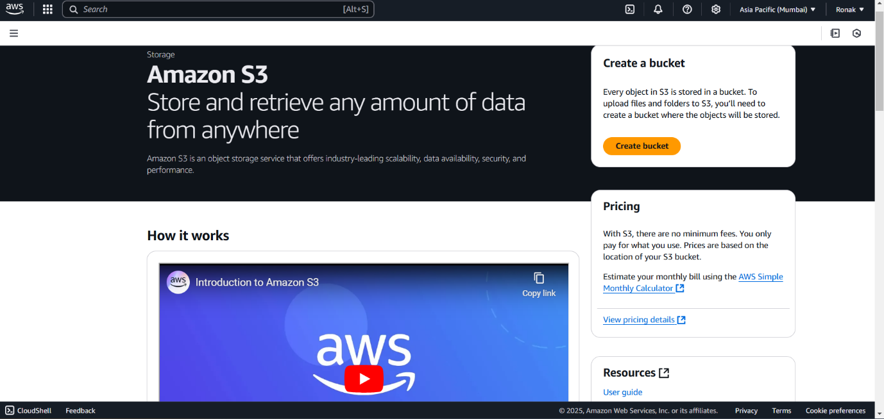
Step 3: Now, click on Create Bucket and you will get these options, now select bucket type and write bucket name.
NOTE: AWS provides a unique Bucket name across the globe so there should be special attention while naming the bucket as per the naming conventions and for more you can also visit See rules for Bucket naming hyperlink present below.
Step 4: Now, select Object Ownership
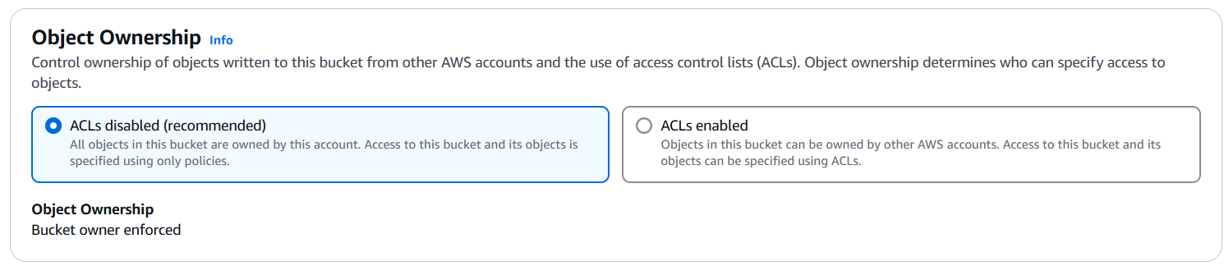
Step 5: Now, you need to check on Public Access, if Public Access is not blocked, the data will be globally available.
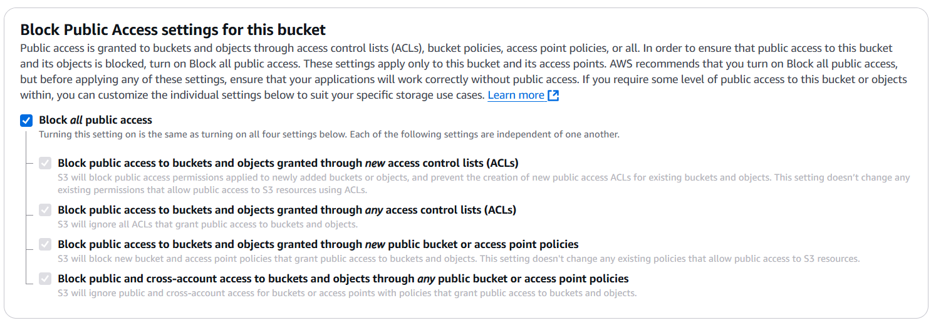
Step 6:
Step 7: Now, select the default Encryption, there are various types of Encryption about which you will get to know in upcoming classes.
Step 8: Now, click on Create Bucket and your Bucket will be created.
Step 9: Now, you can go to this section and will be able to see all the buckets created.
Step 10: And on clicking the bucket you will get option to upload object (Data) like this.

